Build template via Power BI

- Open the file you built in the class. Do not refresh the dataset if you have already downloaded the data.

- Select the following tables: inventory, current inventory_KPI, market, sales, price conditions, production, production order, company value, purchase order

- Sales Sheet (15 points):
We have already built the dashboard in class to answer these questions:
- Which product was sold the best via each channel in terms of net value?
- What are the sales in each distribution channel across the three sales areas?
- What’s the cost per unit, profit per unit, sales quantity, and average price for each product via different distribution channels?

Calculate:
- Cost_per_unit = Divide (sum(cost), sum(quantity))
- Revenue_per_unit = Divide (sum(net_value), sum(quantity))
ASP(average_selling_price) is also revenue_per_unit
In the dashboard, you can draw:
- Column chart: sales quantity of each product by distribution channels
- Clustered column chart: contribution margin of each product by distribution channel
- Table: show quantity, net_value, revenue_per_unit (conditionally formatted), cost_per_unit, CM%, average of unit_price,
- Column chart: sales distribution by sales area
- Slicer: sim_round

- Tasks: please examine sales carefully, list one more question, and answer it in the dashboard.
- Take a screenshot of the sales view and write down the explanations.

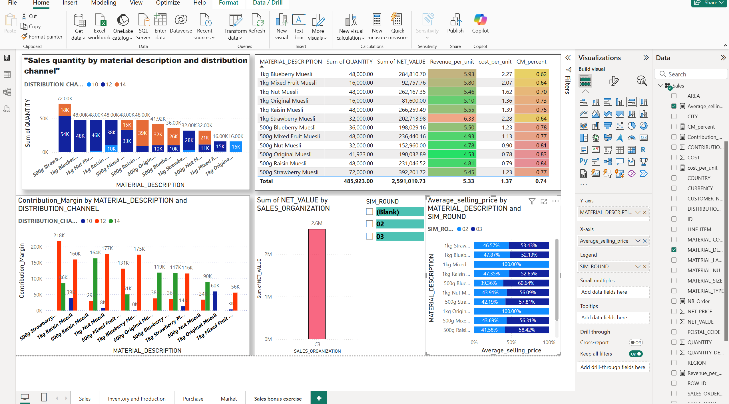

This dashboard provides a detailed analysis of sales performance across different products, distribution channels, and sales areas. The top-left bar chart shows sales quantity by material and channel, indicating that 500g Blueberry Muesli had the highest quantity sold, especially in channel 10. The heatmap-style table in the top-right highlights key financial metrics such as revenue per unit, cost per unit, and contribution margin percentage (CM%). Notably, 500g Raisin Muesli shows the highest CM% at 0.84, making it the most profitable product.
The bottom-left clustered column chart presents the contribution margin by product and distribution channel, clearly illustrating that some products, like 500g Strawberry Muesli, performed particularly well in channel 12. The center bar chart displays total net value by sales organization, where Sales Org C3 dominates with over 2.6M in net sales.
Finally, the bottom-right stacked bar chart tracks the average selling price by material across simulation rounds, showing pricing consistency and variations over time. For instance, 500g Raisin Muesli maintained a stable and high selling price across all rounds.

- Question: Which product has the highest CM% (Contribution Margin %), and how does it compare to other products?"
Answer: 500g Raisin Muesli
- CM_percent ≈ 0.84
- Revenue per unit = 4.81
- Cost per unit = 0.78

- Inventory and production sheet (15 points)

The questions we have already answered in class:
- Which product was produced on each day?
- Did the company fully use its capacity? What’s the production efficiency?
- How many days did the company have no inventory?
Calculate:
- Name capacity: 24000
- Efficiency: = divide (sum(Yield), capacity)
- lost_stock% = Divide(Current_Inventory_KPI[Days_stockout], sum(Current_Inventory_KPI[SIM_ELAPSED_STEPS]))
- Days_stockout: =
Selectedvalue (Current_Inventory_KPI[SIM_ELAPSED_STEPS]) - Selectedvalue (Current_Inventory_KPI[NB_STEPS_AVAILABL
Draw:
- Table: show on_hand, units sold, days available, days stockout
- Column chart: units produced (Yield) by SIM_ELAPSED_STEPS
- Stacked column chart: materials purchase by purchase order
- Stacked column chart: materials purchase by elapsed date
- Slicer: sim round
- Line chart: supplier price change
Tasks: please examine inventory and productions carefully,
- Answer the following questions in the existing dashboard:
How long did it take to order the products? How much did the company order each time?

The company ordered nearly every day, indicating a 1 simulation frequency between orders.

Each purchase order consisted of several items with relatively balanced distribution, roughly 10–20 units per order.
- List one more question and answer it on the dashboard.

Take a screenshot of the inventory and production view, and write down the explanations.

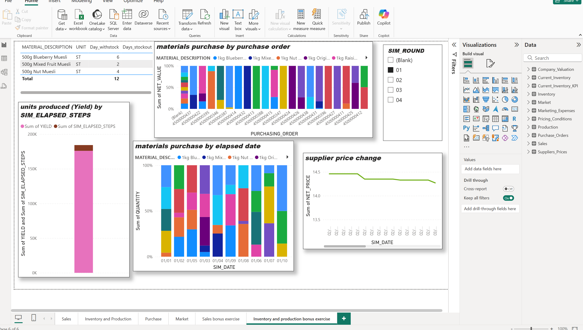

The dashboard provides a comprehensive view of the company’s inventory and production performance. The table in the top left shows stock availability by material, revealing that 500g Blueberry Muesli had the most days in stock. The bar chart titled “units produced (Yield) by SIM_ELAPSED_STEPS” shows total production over time, indicating steady production performance. Stacked column charts display material purchases via purchase order date and simulation date, highlighting normal and balanced ordering of various products. The supplier price trend line reflects a moderate net price drop during the simulation period, reflecting some cost optimization on the part of suppliers. A slicer allows filtering by simulation round, facilitating flexible analysis.

- Market Sheet (15 points)
We have already build the dashboard to answer these questions in class:
  - What’s the value of my company compared with other competitors?
  - What’s the quantity sold by my company compared with other competitors?
Calculate: avg competitors_value, market_value, Market_share
- Company_quantity = calculate (sum (Market[QUANTITY]), Market[SALES_ORGANIZATION]="Company")
- Company_value = calculate (sum (Market[NET_VALUE]), Market[SALES_ORGANIZATION]="Company")
- Market_units = Calculate (sum(Market[QUANTITY]), Market[SALES_ORGANIZATION]="Market")
- Market_value = Calculate (sum (Market[NET_VALUE]), Market[SALES_ORGANIZATION]="Market")
- Avg_competitors_value = Divide ((Market[MARKET_VALUE] - Market[Company_value]), the number of competitor teams)
- Avg_competitor_units = Divide ((Market[MARKET_UNITS]-[COMPANY_UNITS]), the number of competitor teams)
- Company_price = Divide (Market[Company_value], Market[Company_quantity])
- Comptitor_price = Divide (Market[Avg_competitor_value], Market[Avg_competitor_quantity])

Draw
- Table: show distribution channel, Material Descritpion, Net_value, quantity, Average of Price, competitior’s value, market_value, market_share, company_price and market_price

Tasks:
- Please exam market sitaution carefully, answer the following two questions,
- How do you calculate your company's market share?

Market_Share = DIVIDE([Company_Value], [Market_Value])

- Make a comparison of the market situation and company situation, regarding prices and sales revenue via different distribution channels or areas.

Distribution channels: 10,12,14

Channel 10: Company Price is lower than the market average price ( 5.70 vs. 61.48) for products like 1 kg of blueberry muesli, and the Market share is extremely low.

Channel 12: has overall sales (NET_VALUE) and raised company prices, for example 500g Strawberry Muesli: Company Price = 5.29, Competitor Avg = 9.39 and 500g Nut Muesli: Company Price = 5.27, Competitor Avg = 7.82.
Values of Market Shares here are some better, up to 0.22

Channel 14: products like 500g Strawberry Muesli continue to appear
Company Price remains competitive, but market share remains very low (0.16 or lower) and NET_VALUE also lower than in Channel 12

- List one more question and answer it in the dashboard.
Take a screenshot of the market view and write down the explanations.

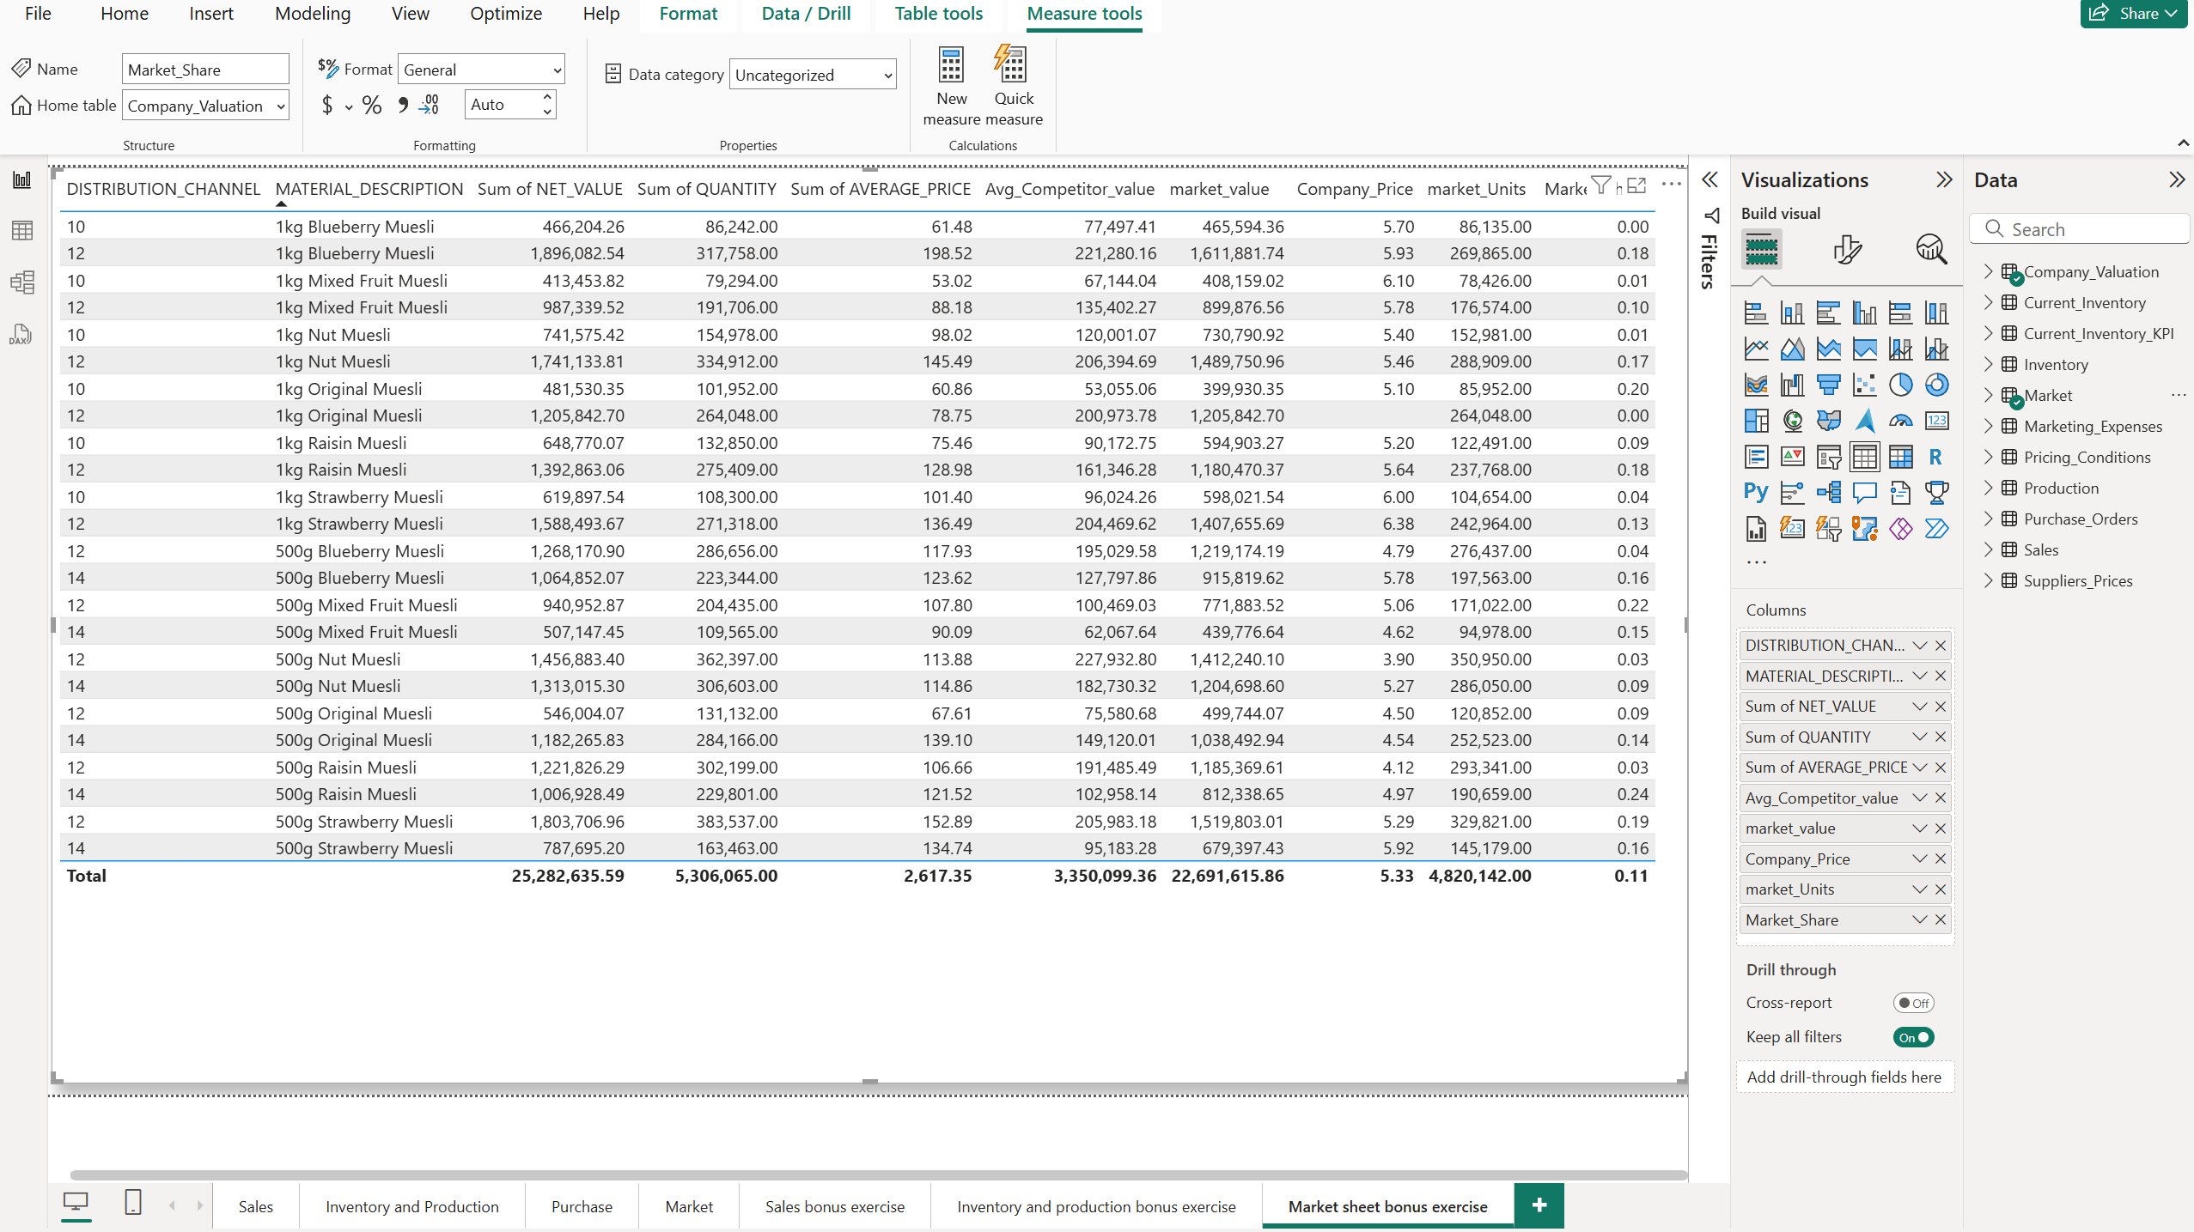

The dashboard provides a comprehensive view of the company's inventory and production performance. The table in the top-left shoes stock availability by material, revealing that 500g Blueberry Muesli had the most days in stock. The bar chart titled “units produced (Yield) by SIM_ELAPSED_STEPS” shows total production over time, indicating steady production performance. Stacked column charts display material purchases via purchase order date and simulation date, highlighting normal and balanced ordering of various products. The supplier price trend line reflects a moderate net price drop during the simulation periods, reflecting some cost optimization on the part of suppliers. A slicer allows filtering by simulation round, facilitating flexible analysis.

- Look at all the tables in the data source, including others we haven’t examined, such as market expenses and company financial value. List the questions, address these questions using the data, and present your solution in a dashboard. You can try to make some predictions for the sales. (15 points)

- What is the company’s financial value trend over time?
- Which marketing channel had the highest spending, and how did it vary over time?

Take a screenshot of the report and write down your explanations of the finding.

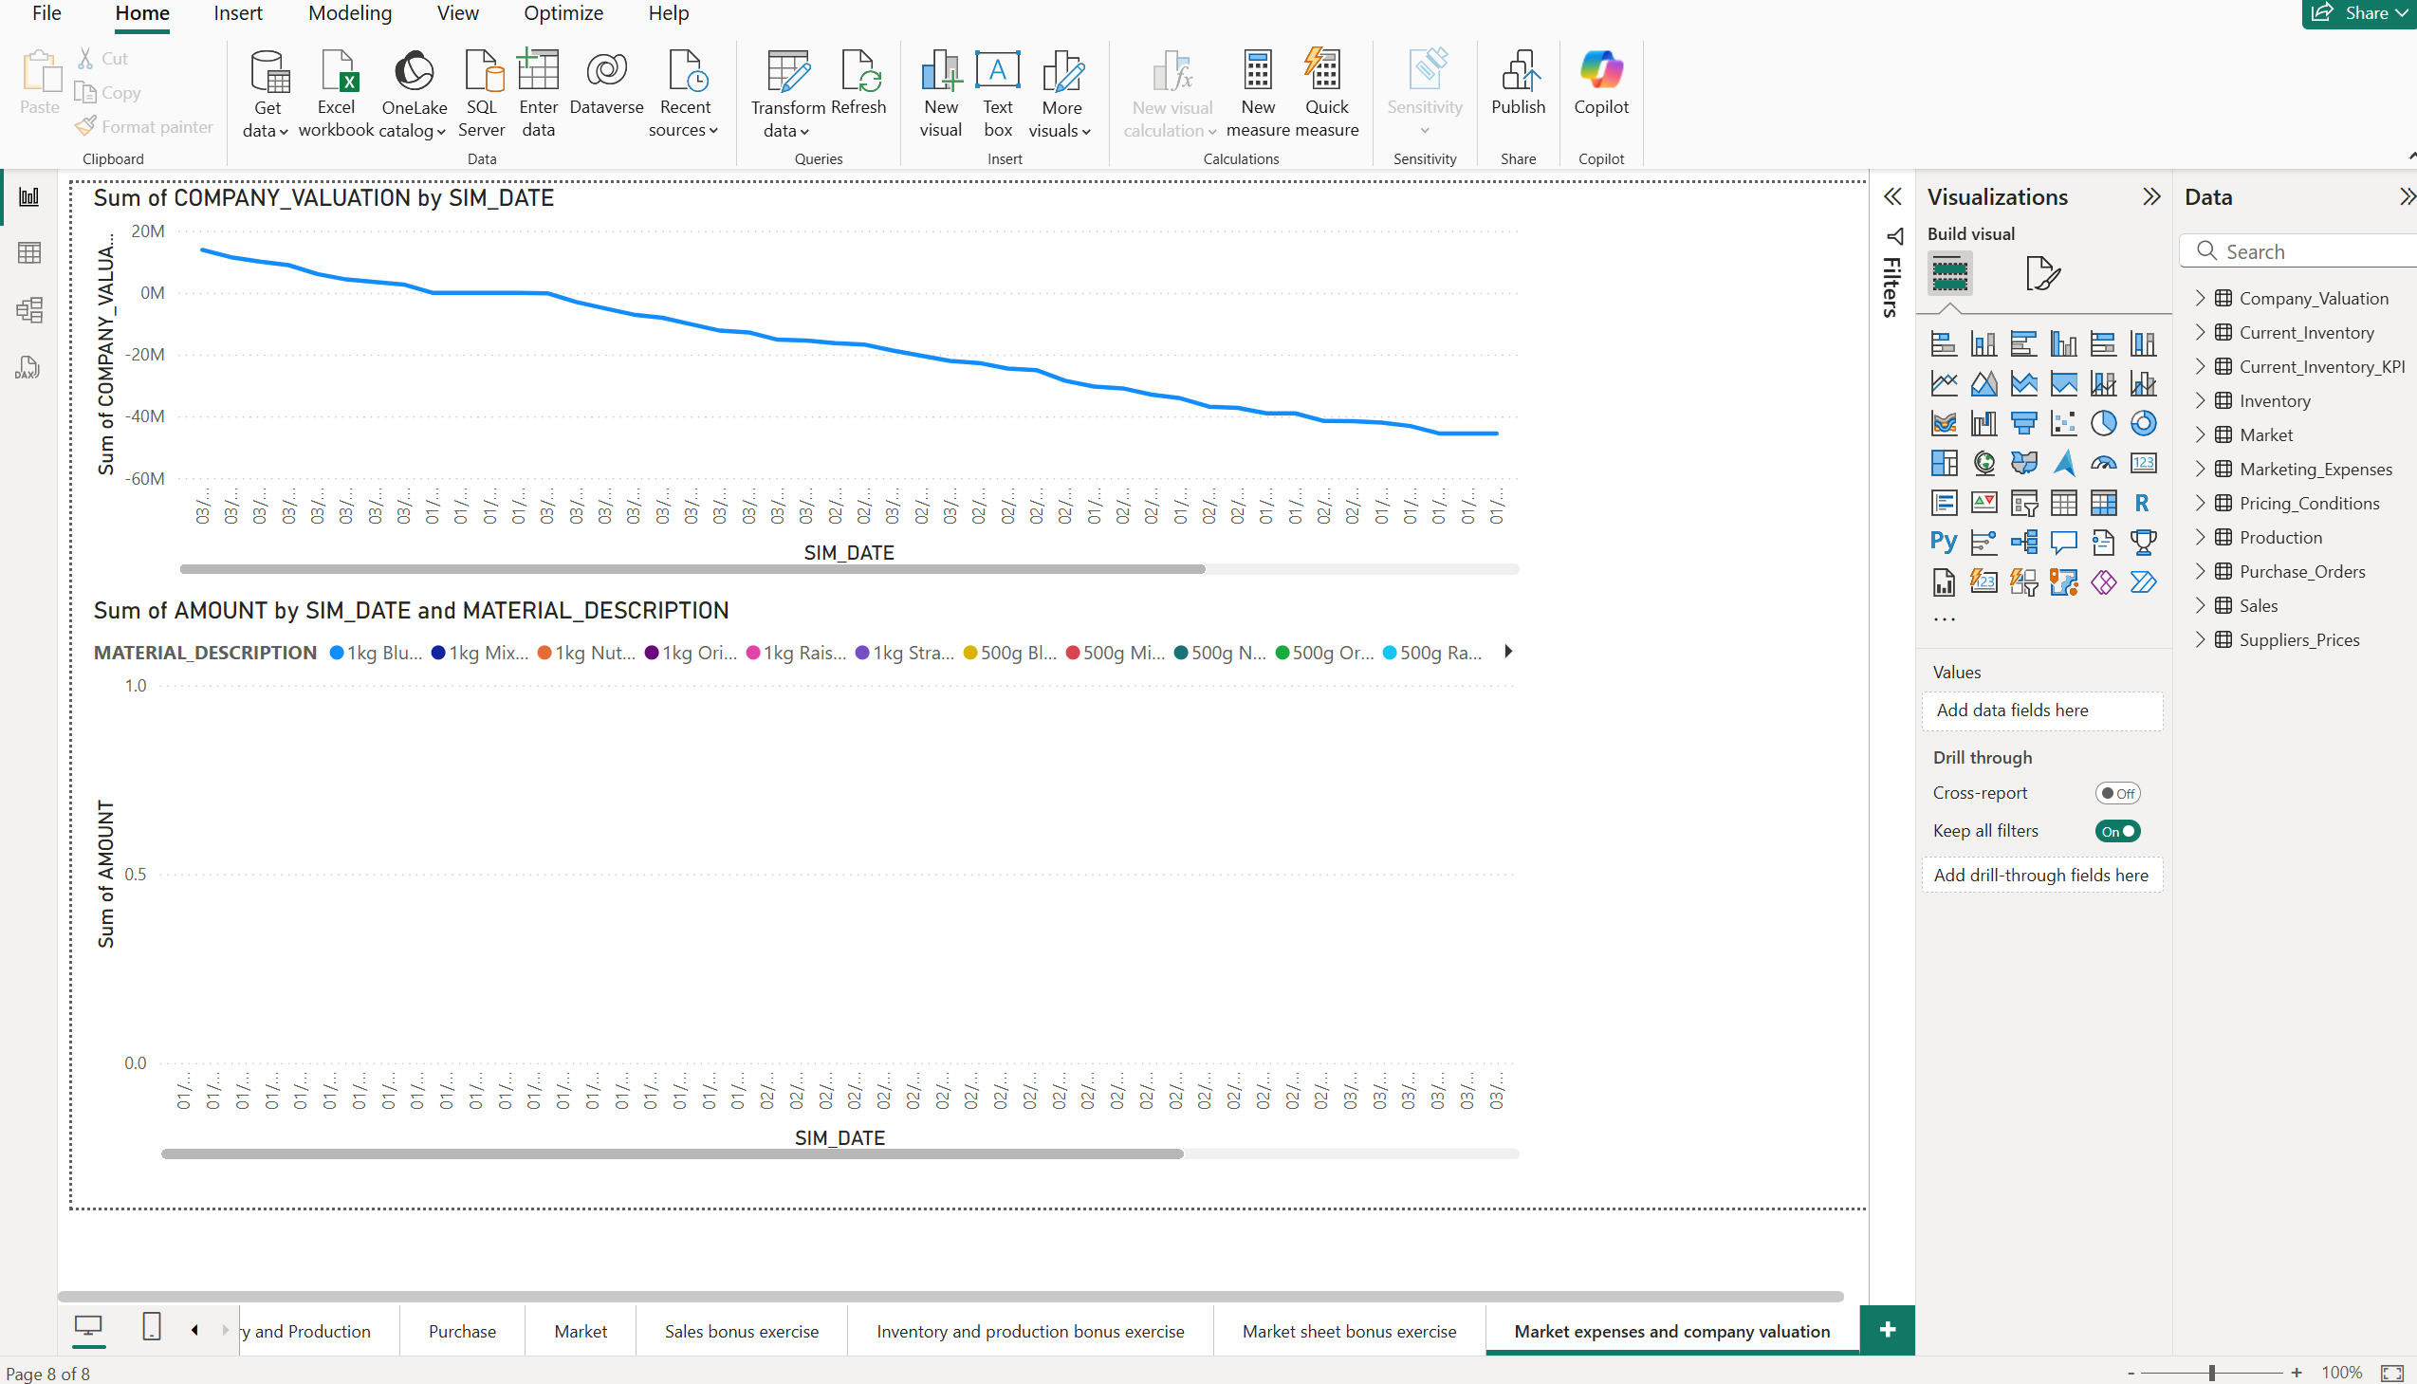

This dashboard gives a more detailed view of the company's financial and marketing dynamics. The top line chart shows a steady decline in company valuation over the simulation period, a sign of an issue with profitability or financial performance. This may be due to poor market share, poor pricing, or rising operating costs. The firm began with a valuation of approximately 20 million, which consistently declined to negative values, which is a net loss scenario.
The second chart, intended to represent marketing cost by material across time, is not displaying any data currently — most likely due to an issue with field reference or the values being aggregated (likely the AMOUNT field has non-matching rows for selected dates or materials).

Please submit the PowerBI file named “Your Last name_first name_data analysis template” and the Word document with all the screenshots and explanations (with the name “Your Last name_first name_data analysis template” ) to the submission link in the Canvas.

